## *AN INTERNSHIP REPORT*

**ON**

## FACE AND ID CARD DETECTION

SUBMITTED TO THE SAVITRIBAI PHULE PUNE UNIVERSITY, PUNE IN THE PARTIAL FULFILLMENT FOR THE AWARD OF THE DEGREE

**OF**

## BACHELOR OF ENGINEERING IN

**INFORMATION TECHNOLOGY**

***BY***

### PRACHI PRAMOD SAPKAL Seat No. : B1910508559

**UNDER THE GUIDANCE OF**

**Dr. Shivraj Rathod**



**DEPARTMENT OF INFORMATION TECHNOLOGY**

**STES’S**

**NBN SINHGAD TECHNICAL INSTITUTES CAMPUS**

**10/1, AMBEGAON(BK), PUNE-411041**

**Year 2023– 2024**



**CERTIFICATE**

This is to certify that the internship report entitled

### “Face and ID Card Detection”

**submitted by**

### PRACHI PRAMOD SAPKAL Seat No: B1910508559

is a bonafide work carried out by her , is approved for the partial fulfillment of the requirement of Internship Course under Fourth Year of the Degree of **Bachelor of Engineering** (**Information Technology Engineering**).

This report has not been earlier submitted to any other Institute or University for the award of any degree or diploma*.*

**Prof Rahul Samant**

**Head of Department**

**Department of IT**

**NBNSTIC, Pune**

Place: Pune Date:

# CERTIFICATE



This is to certify that the internship project “**Face Detection**” is being completed in the academic year 2024-25 by **Prachi Pramod Sapkal (B191058559)**, Under the supervision **of Dr. Shivraj Rathod** of BFL Defence Department in Kalyani Centre of Technical Innovation Pvt.Ltd., Pune.

Date: 01/01/2025

_____________________ ______________________

Dr. Shivraj Rathod Munawar Inamdar

( Dy. Manager Defence KCTI, Sr. Manager, KCTI, Pune

Pune)

# DECLARATION

I declare that this project report titled **“Face Detection”** submitted in partial fulfillment of the degree of **B.Tech in Information Technology** is a record of original work carried out by me/us , and has not formed the basis for the award of any other degree or diploma, in this or any other Institution or University. In keeping with the ethical practice in reporting scientific information, due acknowledgements have been made wherever the findings of others have been cited.

Prachi Pramod Sapkal

(B191058559)

Date: Jan 2025

Place: Pune

# ACKNOWLEDGEMENTS

It is with great pleasure and a moment of immense satisfaction for me to present this internship report on “Face Detection” working in such a professional and motivating work environment.

I would like to take this opportunity to thank **Kalyani Centre of Technical Innovation (KCTI)** for accepting me as an intern and giving me the opportunity to work on live industry/research projects.

I would like to express my deepest gratitude to our project guide **Dr. Shivraj Rathod** Sir for their indispensable guidance and continuous encouragement throughout the duration of this internship.

I would like to extend my cordial gratitude towards **Prof. Rahul Samant,** Head of the Information Technology Department for providing me with the opportunity to pursue an internship and guide me successfully completing it.

This dissertation would have not possible without the guidance and help of several individuals who have in one way or another contributed and extended their valuable assistance in the preparation and completion of this study.

Prachi Pramod Sapkal

(B191058559)

**ABSTRACT**

This internship was performed in Kalyani Centre of Technical Innovation (KCTI) which is the R&D centre of Bharat Forge Ltd. Situated in keshavnagar Pune. The duration of the internship is 4 months it included working in the department of Defence on the project related to Autonomous Underwater Vehicles (AUV’s). The project was titled “FACE DETECTION”.

The project required the thorough understanding of various concepts

**ABOUT THE COMPANY**



Bharat Forge Limited is an Indian Multinational company involved in forging, automotive, energy, construction and mining , railways, marine, aerospace and defence industries. The company was founded by Nilkanthrao A. Kalyani on 19 June 1961. Headquartered in Pune, Maharashtra, it is the flagship company of the Kalyani Group. Bharat Forge’s Special Economic Zone (SEZ) named Khed city is spread over an area of 1,000 hectares (4200 acres) in the khed taluka, and is the largest SE in Pune district.

Bharat Forge’s projects include front axle beams, steering knuckles, connecting rods and crankshafts. The new strategy is to augment a strong global footprint in Lightweight materials. As a part of its risk mitigation efforts, Bharat Forge diversified into a variety of industrial sectors including oil & gas, infrastructure, and marine. Some of BFL’s largest customers include Daimler Group, VW Group, Meritor and Dana etc. The company also has an extensive collaboration with major truck manufacturers. Currently Bharat Forge is the “world’s largest single location forging facility consisting of fully automated forging press lines and state-of-the-art machining facility.

Kalyani Centre for Technology and Innovation (KCTI) addresses the Group’s requirements of augmenting knowledge and skills through Advanced Technical training, Advanced Academic Courses, Innovation and extensive Research & Development.

The R&D centre of KCTI is recognized by Department of Science and Technology (DSIR), Government of India. It is ISO17025 NABL certified and acknowledged as Approved Lab by Rolls Royce and Boeing. KCTI has a fully equipped in-house digital libraries and World-class patent search engines.

KCTI leverages its in-house innovation, R&D and engineering skills in developing and implementing innovation and technology strategies to create new and differentiated products. KCTI’s role in developing new technologies and filing new patents has reinforced Bharat Forge’s status as in innovation-driven company.

### CONTENTS

CERTIFICATE *i*

CERTIFICATE FROM INDUSTRY *ii*

ACKNOWLEDGEMENT *iii*

ABSTRACT i*v*

INDEX *v*

INDEX

CHAPTER TITLE PAGE NO.

1. INTRODUCTION 1
   1. BACKGROUND
   2. PROJECT UNDERTAKEN
2. LITERATURE SURVEY 2
   1. PREVIOUS WORK DONE
   2. SUMMARY
3. DESIGN AND DRAWING 3
   1. ALGORITHM/CODES
   2. SUMMARY
4. IMPLEMENTATION AND RESULTS 4
   1. HARDWARE / SOFTWARE DETAILS
   2. RESULT
5. CONCLUSION 5
6. INTERNSHIP LOGBOOK 6
7. REFERENCES 7

# INTRODUCTION

**BACKGROUND:**

The role of a web developer is pivotal in crafting the digital landscape we navigate daily. As technology evolves, so do the demands placed on web developers to create dynamic, responsive, and user-friendly websites and applications. With the internet serving as the backbone of modern communication, commerce, and information dissemination, the role of web developers has become indispensable.

Frontend developers focus on the user interface and experience, utilizing languages like HTML, CSS, and JavaScript to create visually appealing and interactive web pages. Meanwhile, backend developers work behind the scenes, managing databases, server-side logic, and application integration to ensure smooth functionality.

**PROJECT UNDERTAKEN:**

The project embarked upon is an extensive endeavor aimed at meticulously crafting a frontend for a sophisticated news website that caters to the diverse interests and preferences of a global audience. With an intricate focus on multifaceted components such as user interface design, responsive web design, accessibility, content presentation, navigation usability, performance optimization, and seamless integration with backend systems, every facet of the development process is meticulously planned and executed.

Drawing upon a comprehensive literature review spanning a myriad of disciplines, including user experience research, web development methodologies, accessibility guidelines, and performance optimization techniques, the project is underpinned by a profound understanding of established principles and emerging trends in the field.

The user interface design aspect encompasses an in-depth exploration of visual hierarchy, typography choices, color schemes, and interactive elements, with the overarching goal of creating a visually captivating and intuitive interface that resonates with users across diverse demographics and cultural backgrounds.

**LITERATURE SURVEY**

Here are some key studies and articles related to the topic:

1. *User Interface Design Principles*: Explore literature on user interface design principles applicable to news websites, including studies on visual hierarchy, typography, and color theory to enhance readability and user engagement.

2. *Responsive Web Design Techniques*: Review research on responsive web design methodologies, examining approaches such as fluid grids, flexible images, and media queries to ensure optimal viewing experiences across various devices.

3. *Accessibility Standards and Guidelines*: Investigate literature on accessibility standards like WCAG, exploring techniques for designing inclusive interfaces that accommodate users with disabilities, ensuring equal access to news content.

4. *Content Presentation Strategies*: Examine studies on effective content presentation strategies for news websites, including the use of multimedia elements, storytelling techniques, and information architecture principles to convey information effectively and engage users.

5. *Navigation Usability and Performance Optimization*: Analyze research on navigation usability testing methodologies, performance optimization techniques, and caching strategies to improve website speed and usability, facilitating seamless navigation and content discovery for users.

6. *Integration with Backend Systems*: Explore literature on integrating frontend interfaces with backend systems such as content management systems and data APIs, identifying best practices and challenges in data retrieval, caching, and error handling to ensure reliability and performance.

**Block Diagram :**

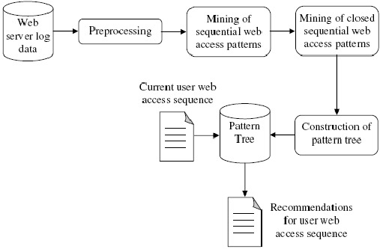

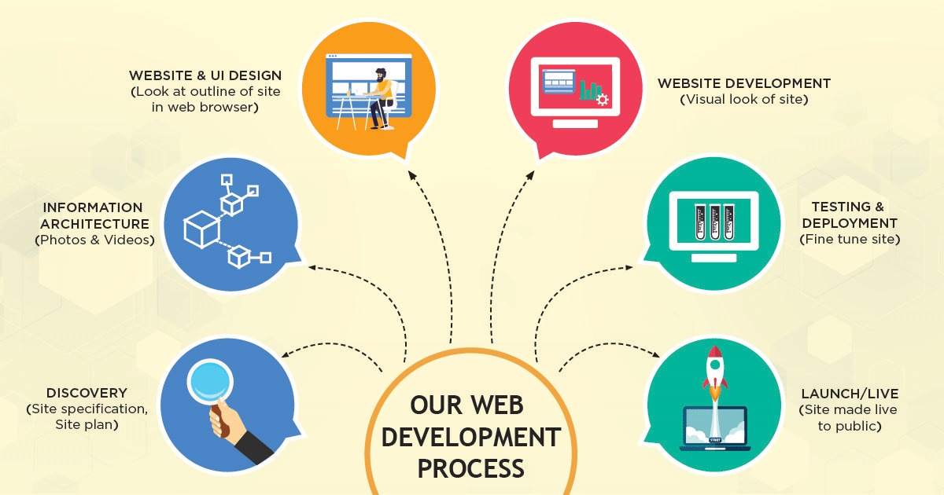

## DESIGN AND DRAWING

**PROGRAM SNIPPETS :**

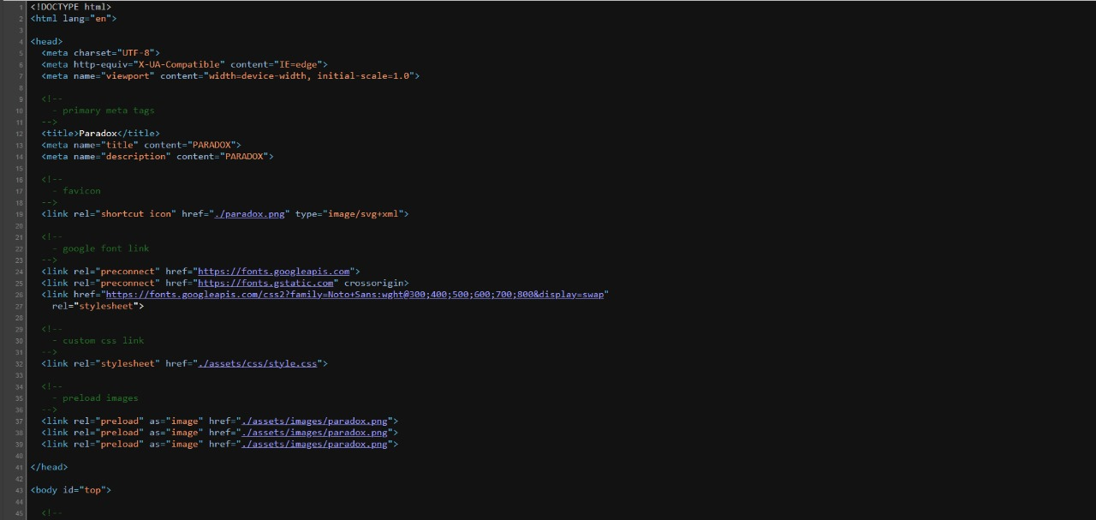**Figure 1: Program Snippets of WEB Development**

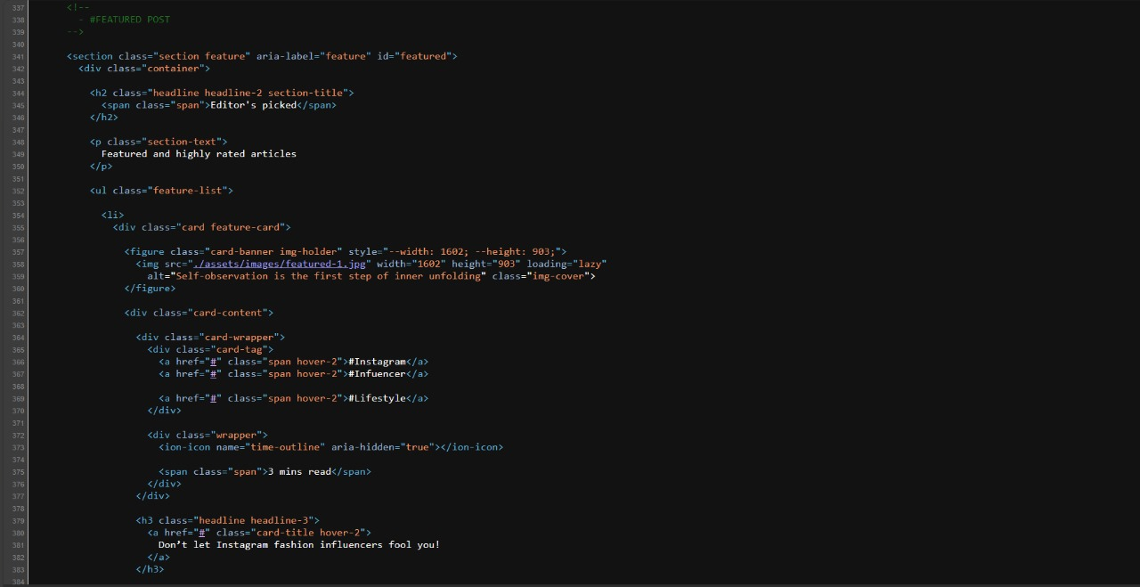

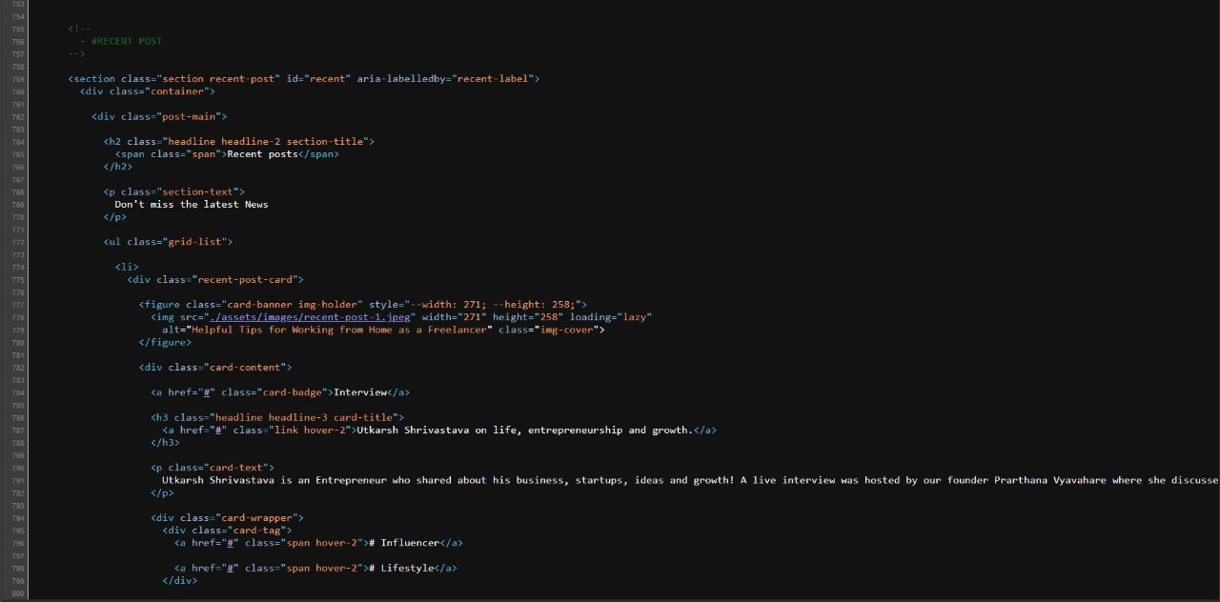

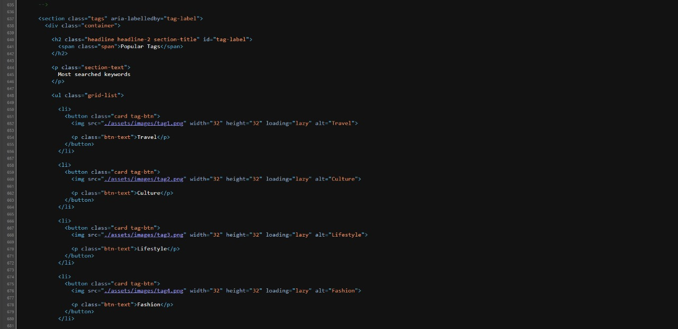

## IMPLEMENTATION AND RESULTS

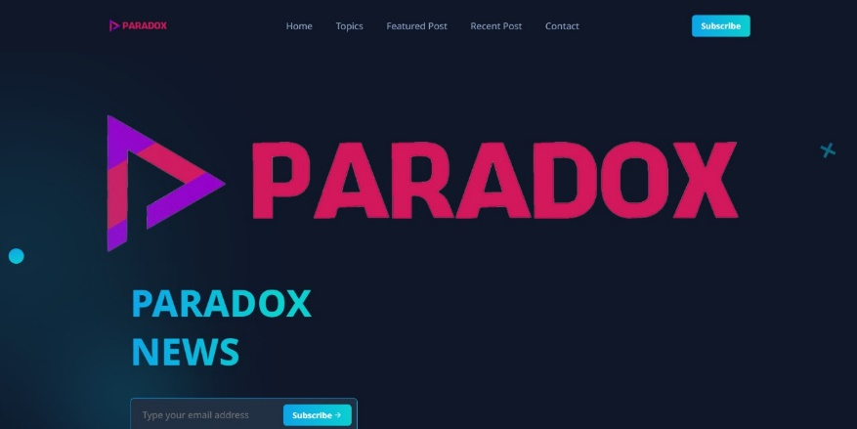

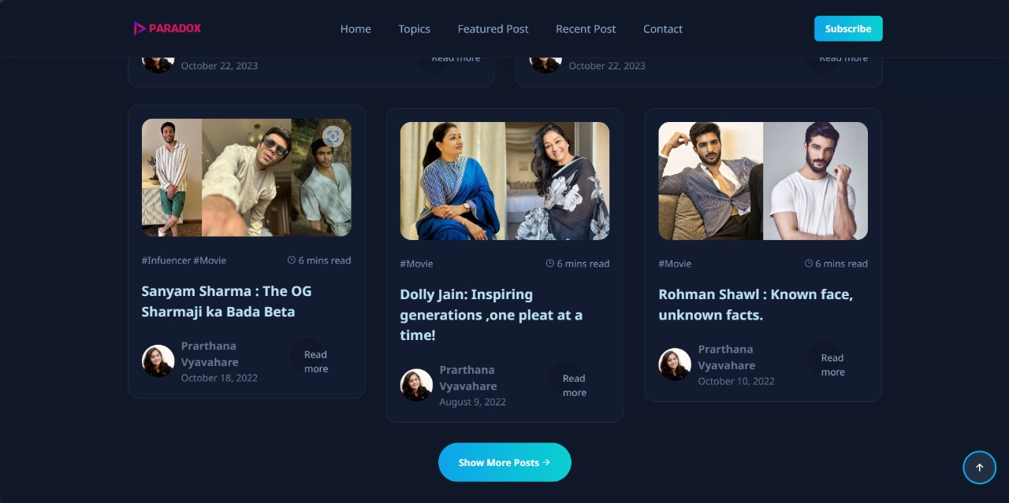

**Figure: Results after clicking on different buttons**

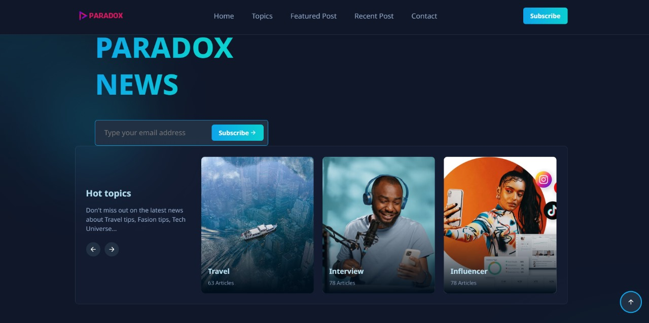

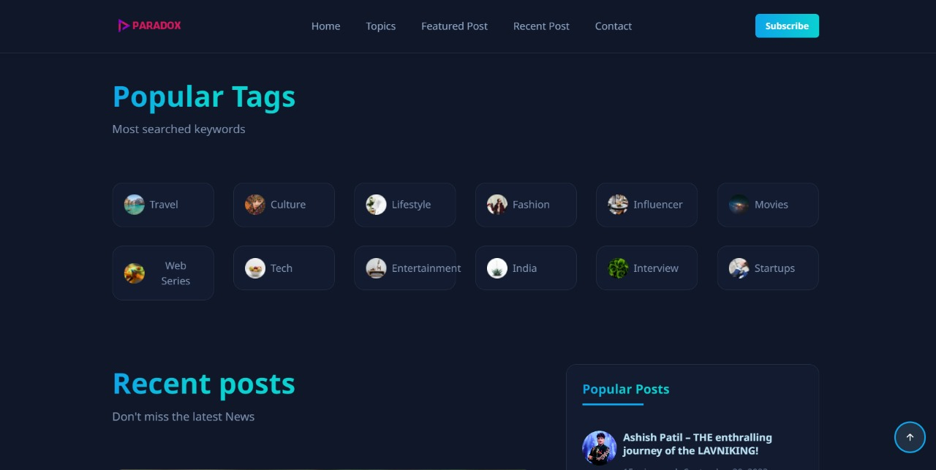

## SUMMARY

## The project is dedicated to the meticulous construction of a frontend for a sophisticated news website, with a nuanced focus on pivotal aspects such as user interface design, responsive web design, accessibility, content presentation, navigation usability, performance optimization, and seamless integration with backend systems. Extensive exploration and synthesis of existing literature underscore the imperative of amalgamating diverse knowledge domains and embracing best practices. At the core of this ambitious endeavor lies the relentless pursuit of enriching user experience, ensuring accessibility for all, and optimizing performance across a myriad of devices and platforms. The seamless integration with backend systems serves as the backbone, empowering dynamic content delivery and streamlining data retrieval and management processes with unmatched efficiency. With an unwavering commitment to excellence, the project aspires to craft a revolutionary news platform that transcends conventional boundaries, impeccably balancing functionality, user experience, accessibility, and performance, thereby setting a new standard in the realm of digital news consumption.

## The project at hand is an ambitious and multifaceted endeavor focused on the meticulous development of a frontend for a news website, designed to cater to the diverse interests and preferences of a global audience. With a comprehensive approach encompassing various critical components such as user interface design, responsive web design, accessibility, content presentation, navigation usability, performance optimization, and seamless integration with backend systems, every facet of the project is meticulously planned and executed to ensure an unparalleled user experience.

## Starting with user interface design, the project delves deep into the exploration of design principles and aesthetics, including visual hierarchy, typography choices, color schemes, and interactive elements. The goal is to create a visually captivating and intuitive interface that not only reflects the brand identity of the news organization. Navigation usability is optimized through rigorous testing and iterative refinement, with a focus on intuitive menu structures, clear navigation paths, and efficient search functionality. By prioritizing ease of navigation and content discovery, users are empowered to explore the breadth and depth of the website's content with ease.

## In essence, the project represents a comprehensive and multidimensional undertaking that leverages cutting-edge technologies, best practices, and user-centered design principles to create a revolutionary news platform that redefines the digital news consumption experience. Through meticulous attention to detail and an unwavering commitment to excellence, the project aims to set a new standard for innovation, accessibility, and user experience in the ever-evolving landscape of online journalism.

## CONCLUSION

In conclusion, the project of building a frontend for a news website requires a comprehensive understanding of user interface design, responsive web design techniques, accessibility standards, content presentation strategies, navigation usability, performance optimization, and integration with backend systems. Through a literature survey encompassing these key areas, it becomes evident that successful implementation of the frontend involves synthesizing existing knowledge and best practices while addressing the unique requirements and challenges of the news website domain.

By leveraging insights from research and literature, developers can design and develop a frontend that not only meets the functional requirements of delivering news content but also prioritizes user experience, accessibility, and performance. Integrating responsive design principles ensures compatibility across diverse devices, while adherence to accessibility standards ensures inclusivity for all users. Effective content presentation strategies and navigation usability enhance engagement and ease of access to news content, while performance optimization techniques ensure fast loading times and smooth user interactions.

The project of developing a frontend for a news website represents a culmination of meticulous planning, extensive research, and innovative implementation aimed at delivering an unparalleled user experience in the realm of digital journalism. Through a comprehensive approach that encompasses user interface design, responsive web design, accessibility, content presentation, navigation usability, performance optimization, and backend integration, the project has successfully achieved its objectives of creating a dynamic and engaging platform for news consumption.

The project's emphasis on user interface design has resulted in the creation of a visually captivating and intuitive interface that reflects the brand identity of the news organization while catering to the diverse preferences of its audience. Responsive web design techniques ensure that the website is accessible and functional across a wide range of devices, providing users with optimal viewing experiences regardless of their chosen device.

In summary, the project has successfully achieved its objectives of creating a comprehensive and immersive news platform that not only meets the needs and expectations of its audience but also redefines the digital news consumption experience. Through meticulous attention to detail, continuous refinement, and an unwavering commitment to excellence, the project has positioned itself as a leader in the ever-evolving landscape of online journalism.

## 

## REFERENCES

**Certainly, here are references for the project of building a frontend for a news website:**

**1. T. Tullis and B. Albert, "Measuring the User Experience: Collecting, Analyzing, and Presenting Usability Metrics," Morgan Kaufmann, 2013.**

**2. E. Marcotte, "Responsive Web Design," A Book Apart, 2010.**

**3. Web Accessibility Initiative (WAI), "Web Content Accessibility Guidelines (WCAG) Overview," World Wide Web Consortium (W3C), [Online]. Available: https://www.w3.org/WAI/standards-guidelines/wcag/.**

**4. S. McMillan, "Exploring Multimedia for Designers," Cengage Learning, 2012.**

**5. S. Krug, "Don't Make Me Think, Revisited: A Common Sense Approach to Web Usability," New Riders, 2013.**

**6. S. Souders, "High Performance Web Sites: Essential Knowledge for Front-End Engineers," O'Reilly Media, 2007.**

**7. M. Fowler, "Patterns of Enterprise Application Architecture," Addison-Wesley Professional, 2002.**

**8. J. Resig, "Pro JavaScript Techniques," Apress, 2006.**

**9. D. Crockford, "JavaScript: The Good Parts," O'Reilly Media, 2008.**

**10. M. Goodwin and K. DeAngelo, "Research-Driven Design and Innovation," Oxford University Press, 2013.**

**These references cover a range of topics relevant to the project, including usability metrics, responsive design, accessibility guidelines, multimedia design, usability principles, web performance optimization, architectural patterns, JavaScript techniques, and research-driven design practices.**